Angeluv Goodies
 |  |  | Prcie
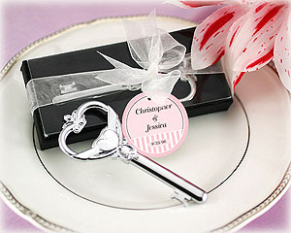 |  | "Key To My Heart" Victorian Style Bottle Opener  Item Number: SBK11003NA  This elegant "Key to My Heart" Victorian Style Bottle Opener makes a unique and elegant favour. Made of high quality chrome, the silver opener is shaped like an antique key. Our chrome favours are solid chrome-with a notable weight and lasting quality. Each opener is presented in a black velvet lined gift box with a clear top. The favour is complete with a sheer organza ribbon and a designer hang tag that reads "Key to My Heart." The key opener measures 10cm x 3.8cm and each gift box measures 12.7cm x 5cm. | R29.50
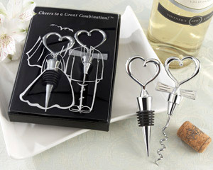 |  | "Cheers to a Great Combination" Wine Set  Item Number: SBK11005NA  “Eat, Drink and Be Married!” On the day your two loving hearts become forever joined, thank your guests for sharing the moment with a cleverly packaged, fun favour. This whimsical wine set with its heartwarming design creatively celebrates the bride and groom's great combination! Features and facts:  - Wine set includes chrome heart bottle stopper and “tuxedo tie” heart corkscrew  - Bottle stopper measures 4 ½” long  - Corkscrew measures 5” long  - Gift box includes black, velvet-lined interior, black base and clear cover with playful bride-and-groom design and the words “Cheers to a Great Combination!”  - Gift box measures 6 ½” h x 4 ½” w x 1” d | R75.00
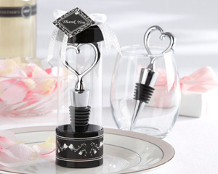 |  | Sterling Heart Bottle Stopper in Tall Showcase Display Box  Item Number: 11010NA  Capture the hearts of your guests with this elegant, contemporary and practical bottle stopper topped with the definitive symbol of love. The sleek, openwork heart expresses the moment like nothing else can. One of our most popular and beautifully crafted favours, the heart bottle stopper in its exquisite showcase gift box adds sophistication and sparkle to your table decor. Features and facts:  - Our chrome bottle stopper is solid chrome, with a notable weight and lasting quality  - Bottle stopper is 4 ½" long  - Cylindrical showcase gift box has a black-and-white floral print base, clear display window, a black cap accented with a sheer organza bow and a "Thank You" tag that matches the design on the base  - Gift box stands approximately 6" high | R48.50
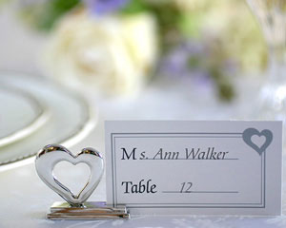 |  | 'Playful Hearts' Silver Placecard Holders with Matching Place Cards (Set of 4)  Item Number: SBK11016NA  A playful heart is certainly full of joy, and we like to think these place card holders, with their carefree sculpting and shiny silver chrome, are both playful and elegant. Each heart place card holder makes a charming presentation at your event tables. Features & Facts:  - Designer place cards are included  - Sold as a set of 4  - Measures 3.2cm x 2.9cm | R55.00
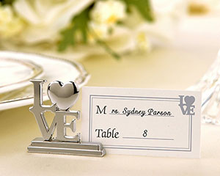 |  | "LOVE" Place Card Holder/Photo Holder with Matching Place Cards (Set of 4)  Item Number: SBK11017NA  It's the little things that often make the biggest statement! Share your LOVE with these meaningful place card holders that your guests will love using as photo holders at home!  Features and facts:  • Crafted of quality chrome  • LOVE is in two rows of block letters, with a heart representing the O  • Includes designer place cards  • Measures 3.2cm x 3.2cm  • Sold in a set of four | R76.17/4
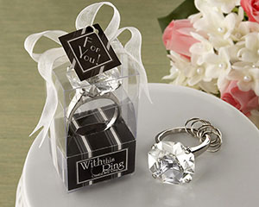 |  | "With This Ring" Engagement Ring Keychain  Item Number: SBK11020NA  Sparkling from every facet, this beautiful crystal "diamond" is a stunning, oversize replica of the real thing, with enough expertly designed details to turn heads! As you've probably guessed, these exquisite engagement-ring key chains make excellent bridesmaids favours and gifts for bridal shower guests? Features and facts:  - Chrome ring includes several key chain hoops  - Showcase “ring” box with sheer white, organza bow and matching "For You" tag. | R42.50
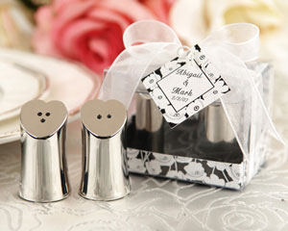 |  | "Seasoned with Love" Heart-shaped Salt and Pepper Shakers in Elegant Gift Box  Item Number: SBK11028NA  Every reception or dinner table could use a dash of love and appreciation, and what better way to convey such affection than with salt and pepper shakers that are just brimming with dainty charm? Made of chrome, each set is cute enough for everyday use but elegant enough for your most formal affairs. Sold together in a showcase gift box decorated with beautiful poppies and tied with organza ribbon with matching “Thank You” tag. Shakers measure 7/8” wide by 1.5” tall. | R41.50
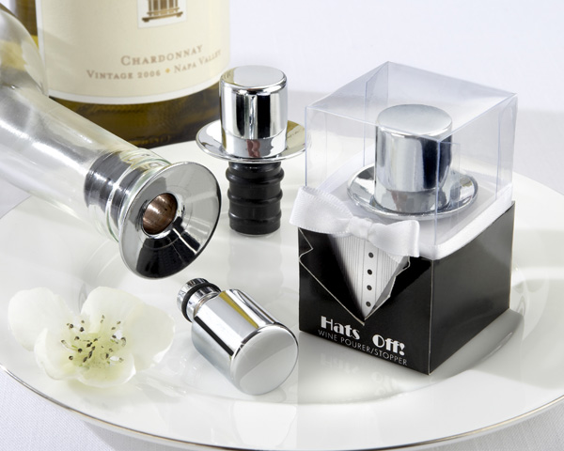 |  | Hats Off! Chrome Top Hat Wine Pourer/Bottle Stopper  Item Number: SBK11033NA  Adorably handsome is the only way to describe this original—not only the favour, but the spectacular gift-box design as well! The dapper, chrome top hat tops off bottles with class and pours with perfection. Time for the tuxedos to take top honors! Features and facts:  - Top hat-shaped pourer/bottle stopper is made of solid chrome, with a notable weight and quality  - Stopper measures 2" h x 1 1/2" in diameter (at widest point)  - Showcase gift-box design includes a clear top and black, tuxedo-style base, with black buttons on a white, tuxedo shirt, cutout tuxedo lapels and an aristocratic, white, satin "bow tie"  - Gift box measures approximately 2 3/4" h x 1 3/4" w x 1 3/4" d | R48.50
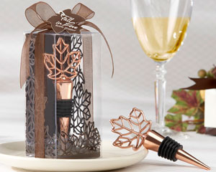 |  | “Lustrous Leaf” Copper-Finish Bottle Stopper in Laser-Cut Leaf Gift Box  Item Number: SBK11038NA  As visually stunning as a magnificent maple tree ablaze with autumn’s most vibrant colors—the “Lustrous Leaf” Copper-Finish Bottle Stopper is a masterfully designed favour that says something unique about the person who thanks her guests with such a dramatically different gift. Features and facts:  • Leaf-shaped stopper is crafted from heavy metal with a copper finish  • Showcase gift box features chocolate-brown, laser-cut leaves, brown organza bow and leaf-shaped “For You” tag  • Stopper measures 4 ½” h x 1 ½” w  • Gift box measures 4 ¾” h x 2 ¼” x 2”d | R55.00
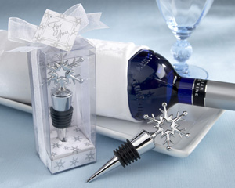 |  | Snowflake Bottle Stopper in Shimmering Gift Box  Item Number: SBK11039NA  Like icicles on a crystal clear winter day, these chrome snowflake bottle stoppers bring the essence of the season to any occasion. Imagine the winter wonderland created for your guests at every table when they see this beautiful and practical favour, crowned by an ornately crafted snowflake, just waiting to be taken home. Features and facts:  - Bottle stopper measures 4 ½” x 1 ½”  - A pearlescent white gift box surrounds the stopper with a shower of silver snowflakes  - Gift box is accented with a sheer white organza ribbon and a snowflake-studded "For You" tag | R36.00
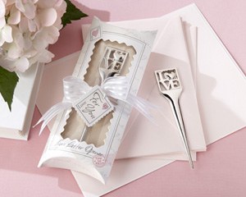 |  | "L-O-V-E" Chrome Letter Opener in Pillow Box Packaging  Item Number: SBK11041NA  Words of L-O-V-E, so soft and tender... A classic, highly celebrated favour has inspired a spectacular, new gift presentation both heartwarming and clever. You’ll know at once it’s the “write” choice for your guests. Our pretty and practical, 10.8cm x 2.5cm chrome L-O-V-E Letter Opener (the “O” in “L-O-V-E” is a full heart) is perfectly showcased in a cream-colored, 16.5cm x 7cm w x 2.5cm d pillow box with a scalloped, clear window and the words “Love Letter Opener” at the bottom. Accenting the window are a “stamp” and a postmark. The stamp has a delicate pink heart and the word “Love.” The pink postmark says “Postage Paid With Love” along with “xo” (kisses and hugs!) A soul-stirring love letter in pale silver on the gift box, lends even more romantic interest. Tied around the center of the box are a charming, organza-and-satin-striped bow and a “For You” tag that matches the stamp on the pillow box. Simple, sentimental and absolutely stunning! | R36.50
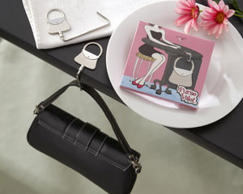 |  | Purse Valet Stainless-Steel Handbag Holder  Item Number: SBK11043NA  What woman hasn't struggled with the problem of where to park her purse at restaurants, meetings and other occasions? Sling it over the back of the chair? Too vulnerable. Keep it in your lap? Too awkward. Place it on the floor? Ewwww. Imagine how thrilled the guests at your bridal shower will be when they find you've chosen the "Purse Valet" Stainless-Steel Handbag Holder for their favours! Features and facts:  - The 4.4cm x 3.8cm silver-tone purse sits on the tabletop and 8.2cm metal hanger drops under the table  - Cute, cleverly designed, colorful 11.4cm x 10cm gift box demonstrates use  - Fits easily in any purse | R37.00
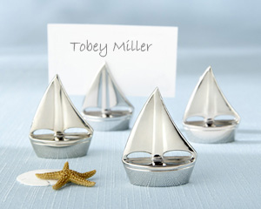 |  | “Shining Sails” Silver Place Card Holders (Set of Four)  Item Number: SBK11044NA  When the sea beckons, love sets sail near the splendor of a sun-drenched shore. Create the ambience only a beach wedding can inspire by making your tables an ocean full of glistening silver sailboats with these “Shining Sails” Place Card Holders—each one a paragon of stunning simplicity. The sailboats measure 3.8cm x 3.1cm x 1.3cm and are sold as a set of four. | R55.00
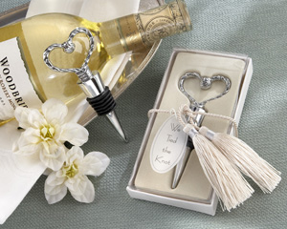 |  | “We Tied the Knot” Elegant Chrome Braided-Heart Bottle Stopper with Tassels and Pearlized Tag  Item Number: 11045NA  Behold a gleaming, braided heart with the two halves meeting in the center to form a lasting knot. It is simply the perfect symbol of your love and the day you’re celebrating. Long after the moment has gone, each of your guests will remember you tied the knot, because you chose to thank them with these exquisite, chrome bottle stoppers.  The heart is a chrome braid that’s “tied in a knot” at the top. Adding to the sophistication of the favour is a stunning presentation. The ivory display gift box is bound by ivory braid with two silver-trimmed tassels flowing from the knot and a pearlized, vellum tag that reads “We Tied the Knot.” Sure to create a buzz at your reception, the bottle stopper measures 4” h x 1 ½” w, and the gift box is 5 ¼” h x 2 ¾” w x 1” d. As always, all of our bottle stoppers in chrome, giving them a nice weight in the hand and ensuring that these popular favours will be enjoyed for years to come | R48.50
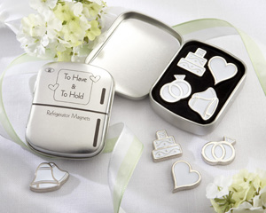 |  | “To Have & To Hold™” Set of Four Magnets in Classic “Refrigerator” Tin  Item Number: SBK11048NA  Tell us! Was it his magnetic personality that attracted you to him? When you both make the promise to have and to hold, celebrate your mutual attraction with a clever original! Send your guests home with a refrigerator full of symbolism—a magnetic memento they'll have to hold cherished photos, kids' drawings and daily reminders in a convenient place. A fanciful favour so captivating, your guests will certainly know that he was attracted to your flair for the unique and your excellent taste! Features and facts:  - The outside of the silver-finish tin favour is a "refrigerator" with heart magnets securing an important reminder that says "To Have & To Hold" with "Refrigerator Magnets" just below  - Inside are four petite, yet powerful silver-finish metal magnets with white enamel accents—a heart, two rings, wedding bells and a three-tier cake  - The refrigerator tin measures 6.3cm h x 5cm w x 1.9cm d | R41.50
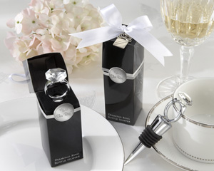 |  | “With This Ring” Chrome Diamond-Ring Bottle Stopper  Item Number: SBK11057NA  You know that feeling you get when he's on his knee and opens the ring box? Wedding guests will get that same rush of excitement when they open this ultra-creative gift box to find—what else? An engagement ring sitting atop a bottle stopper! A simply breathtaking favour! Features and facts:  - Mega-carat, multi-faceted crystal stone rests in a chrome setting above the chrome bottle stopper  - Bottle stopper measures 10cm h x 2.5cm w  - Stunning gift box opens like a ring box near the top to reveal the engagement ring on a black-velvet base; exterior of box is classic black with silver trim where the box opens, a round, silver appliqué that says “With This Ring,” the words Diamond Ring Bottle Stopper at the bottom of the box, and a pure-white, satin bow with a gift-box charm at the top  - Gift box measures approximately 10cm h x 3.8cm w x 3.8cm d | R48.50
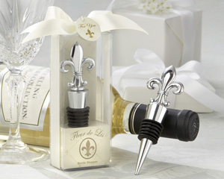 |  | “Fleur-de-Lis” Elegant Chrome Bottle Stopper  Item Number: SBK11058NA  A legendary symbol of elegance, nobility and grace, the fleur-de-lis has made its way to the top into the legendary line of solid-chrome bottle stoppers, all with a notable weight and quality. From a casual dinner party to the grandest of weddings, the “Fleur-de-Lis” Bottle Stopper is a favour befitting any occasion. Features and facts:  - The fleur-de-lis is detailed on both sides of the chrome bottle stopper  - Bottle stopper measures 4 ½” h x 1 ¼” w  - Clear display gift box holds a cream-colored, fleur-de-lis, design background and base with Fleur-de-Lis Bottle Stopper imprinted on the front of the base  - Gift box is accented with a cream-colored ribbon and bow and a coordinated “For You” tag | R48.50
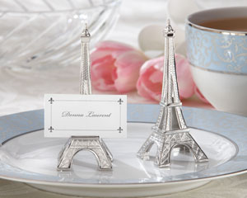 |  | “Evening in Paris” Eiffel Tower Silver-Finish Place Card/Holder (set of 4)  Item Number: SBK11063NA  Ooh, la la! Destination Paris! The enchanting City of Light is one of the most romantic places on earth—you might even call it the City of Love, and Sparkling Bride’s "Evening in Paris” Eiffel Tower Place Card Holder is quickly becoming a renowned landmark in the wonderful world of favours. When your event has a distinctly French flavour, favour your guests with a thank-you gift that's magnifique! Features and facts:  • Finely detailed, silver-finish replica of the Eiffel Tower  • Small ledge on lower "deck" holds place card or photo  • Favour measures 10cm h x 3cm w  • Place cards are included  • Sold in a set of four | R90.50/4
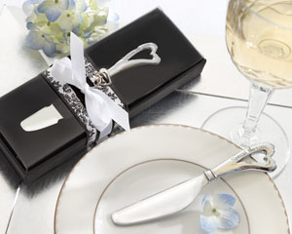 |  | “Spread the Love” Chrome Spreader with Heart-Shaped Handle  Item Number: SBK 11064NA  As beautiful as the meaning behind it, the "Spread the Love" Chrome Spreader is everything an elegant wedding favour should be—designed for today's contemporary tastes, practical, sparkling with style and impressively gift-wrapped. Simply putting this gorgeous thank-you gift at each place setting intensifies the impact of your reception tables!  Features and facts:  • Gleaming chrome spreader with contemporary, heart-shaped handle  • "Spread the Love" engraved along one side of the heart  • Spreader measures 4 ¾" l x ¾" w | R47.50
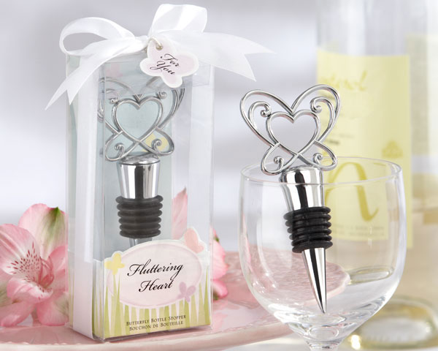 |  | Fluttering Heart Butterfly Chrome Bottle Stopper  Item Number: SBK11073NA  Someone once said, "Love is like a butterfly. It goes where it pleases, and it pleases wherever it goes." Perhaps that's why the“Fluttering Heart” Butterfly Chrome Bottle Stopper, magnificently marrying both the symbol of love and the butterfly, has a remarkably pleasing effect on guests at any event. Family and friends will remember your heartfelt thank-you and the wonderful celebration that brought you all together. Features and facts:  - Artistically designed, chrome bottle stopper with a notable weight and quality  - Elegant, heart-inspired, openwork butterfly at the top  - Bottle stopper measures 4 ¼ " h x 3 ½ " w  - Gift presentation includes clear, showcase gift box, beautiful graphic of yellow, lavender and pink butterflies winging through the sky, a white-satin ribbon and bow, and a butterfly-shaped "For You" tag  - Gift box measures 5" h x 2" w x 1 ¼ " d | R36.00
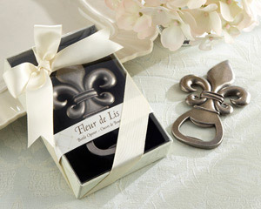 |  | "Fleur de Lis" Pewter-Finish Bottle Opener  Item Number: 11079NA  For centuries, the fleur de lis has been, among other things, the epitome of uncompromising elegance in design. With our "Fleur de Lis" Pewter-Finish Bottle Opener, we’ve married the aura and artistry of a bygone age with the practicality of a kitchen, bar and picnic-basket essential. Simply a classically crafted souvenir to cap off a lovely occasion!  Features and facts:  • Exquisite pewter-finish bottle opener with fleur de lis design  • Bottle opener measures 3 1/2" h x 2 1/4" w  • Gift presentation includes delicate, cream-colored fleur de lis-themed gift box with clear, display cover, a coordinated band that says Fleur de Lis Bottle Opener and a cream-colored satin ribbon and bow  • Gift box measures approximately 4 1/4" l x 3" w x 1" d | R51.00
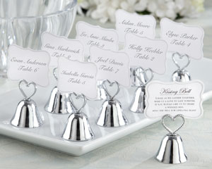 |  | "Kissing Bell" Place Card/Photo Holder (Set of 24)  Item Number: SBK 12006NA  Bells will ring joyfully on your wedding day, when a single kiss at the altar changes your life forever! Give your guests—and yourselves—the pleasure of reliving the moment over and over again with our "Kissing Bell" Place Card/Photo Holder with a braided-heart handle. A sweet poem on the back of the place cards invites guests to "ring" for a kiss from the happy couple. Start smooching! Features and facts:  - Sweet, silver-finish metal bell place card/photo holder with braided, openwork heart handle  - Bell measures 1 ¾" h x 1 ¼ " in diameter  - Coordinating place cards included  - One side of place card has space for a name, the other side is imprinted with this poem: "Today, as we gather together, wish us a love to last forever. If you would like us to share a wedded kiss, ring the bell for lifelong bliss."  - Sold in a set of 24 | R515.00/24
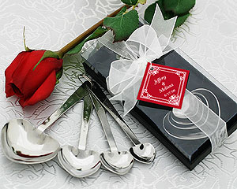 |  | "Love Beyond Measure" Heart-Shaped Measuring Spoons in Gift Box  Item Number: SBK13001NA  Love is like cooking. When you combine the right ingredients, the result is heavenly! These pretty and practical heart-shaped measuring spoons will give your guests all they need to cook with love. Each set of four spoons features "measures of love" on one side with traditional measurements on the other. "A Pinch of Patience" = ¼ teaspoon, "A Dash of Kindness" = ½ teaspoon, "A Spoonful of Laughter" = one teaspoon, and "A Heap of Love" = one tablespoon. Features and facts:  - Measuring spoons are crafted from stainless steel  - Black velvet-lined gift box measures 6” x 1 3/8” x 2 ¾”  - Gift box includes sheer, white organza bow and a silver-heart tag that reads “Love Beyond Measure” | R44.50
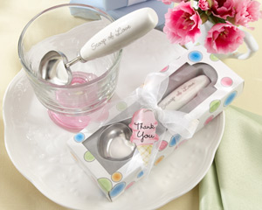 |  | "Scoop of Love" Heart-Shaped Ice Cream Scoop in Parlor Gift Box  Item Number: 13004NA  Just the thing to scoop up delicious memories and more! This heart-shaped ice cream scoop mixes sweetness with functionality for a “thank you” gift that will bring years of smiles—and ice cream sundaes—to your guests. Features and facts:  - Stainless-steel, heart-shaped scoop  - Rounded, white, porcelain handle has tiny heart accents and the words “Scoop of Love” in elegant, silver script  - Scoop with handle measures 5 ¼” x 1”. Scoop alone measures 1 ¾” x 1 ½ “  - White gift box has pastel, ice cream parlor theme, a sheer, white organza bow and ice cream cone-shaped “Thank You” tag  - Gift box measures 7” x 2” | R60.00
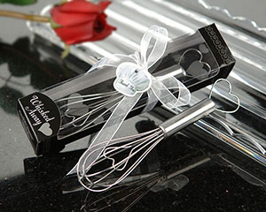 |  | "Whisked Away" Heart Whisk  Item Number: SBK13009NA  Whisk a little love and affection into every dish with this whimsical favour. Each stainless-steel whisk has a cleverly enclosed heart and heart-shaped handle top. Let your guests cook up some magic with a heartfelt reminder of your gratitude. Features and facts:  - Stainless-steel whisk with heart motif  - Whisk measures 15cm x 4cm w  - Elegant black gift box accented with sheer, white organza ribbon and chef's hat-shaped “Thank You” tag  - Gift box measures 18cm x 4cm w | R27.00
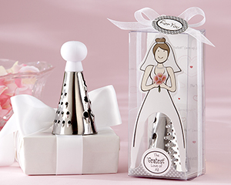 |  | “The 'Gratest' Love of All” Stainless-Steel Cheese Grater in Showcase Gift Box  Item Number: SBK13014NA  Here comes the bride, looking radiant—as all brides do—and wearing a "grate" gown! In a gift presentation as memorable as the favour itself, "The 'Gratest' Love of All" Stainless-Steel Cheese Grater blends romance and fun in a warm and whimsical way. Features and facts:  - Cardboard-cutout bride, in traditional white, poses in front of a heart-covered background with the phrase The "Gratest" Love of All repeated throughout  - Her one splash of color is the lavender-and-red bouquet she carries  - The skirt of her gown is the stainless-steel cheese grater, which has three hole sizes for fine and coarse grating  - Hidden behind her is the round, white plastic handle of the grater  - Clear gift box says The "Gratest" Love of All at the bottom of the box, which is exquisitely accented by a lovely, sheer white organza bow and a matching "For You" tag  - Grater measures 8.9cm high x 5cm in diameter  - Gift box measures 14cm x 6.3cm x 5cm | R36.00
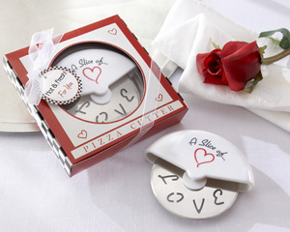 |  | "A Slice of Love" Stainless-Steel Pizza Cutter in Miniature Pizza Box  Item Number: SBK13015NA  No matter how you slice it, there's simply no topping Sparkling Bride when it comes to creative wedding favours! Place “A Slice of Love” Pizza Cutter next to each table setting, and when your guests go home, they'll take a “pizza” your heart with them—in a deliciously designed pizza box! Features and facts:  - White, protective, plastic grip says "A Slice of..." just above a saucy, red heart, with the letters L-O-V-E appearing as openwork on the stainless-steel cutter  - Pizza cutter is cleverly packaged in a miniature, red-and-white pizza box with black-and-white checkered sides and a circle of clear cellophane on top that lets the pizza cutter peek through  - Pizza box is tied with a sheer white, organza ribbon and bow and includes a matching tag that says "Hot & Fresh For You"  - Pizza cutter measures 9.5cm in diameter, and the gift box measures 11.4cm square | R34.50
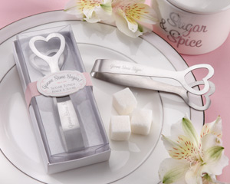 |  | "Gimme Some Sugar!" Stainless-Steel Heart-Themed Sugar Tongs  Item Number: 13029NA  Sweetheart. As wonderful to say as it is to hear--for soon-to-be-wed sweethearts and little ones, too! Inspired by this single word, the designers created "Gimme Some Sugar!" Sugar Tongs for the sweetest thank-you your bridal shower or baby shower guests could ever imagine! Features and facts:  • Stainless-steel, heart-shaped sugar tongs engraved with Gimme Some Sugar!  • Tongs measure approximately 4" h x 1 1/4" w  • White gift box with clear, showcase cover, delicate pink-and-white lattice background behind tongs, and pink-and-white-striped belly band with applique that reads "Gimme Some Sugar" Sugar Tongs  • Gift box measures 4 3/4" h x 2" w x 1" d | R33.50
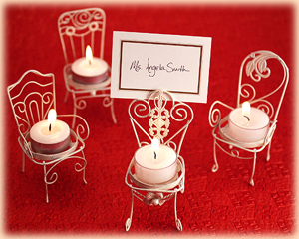 |  | Set of 4 "Be Seated" Victorian Chair Tealight Place Card Holder  Item Number: SBK14001NA  These elegant "Be Seated" victorian Chair Tea-light Place Card Holders bring a beautiful touch to reception tables. Each chair is handcrafted from metal and then hand painted for a brushed antique finish. The elegantly designed chairs measure 11.4cm x 6.3cm, and the standard tealight is included. These adorable chairs double as a keepsake favour as guests can later use these as a tealight holder or to hold their own photos. | R65.00/4
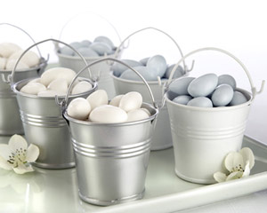 |  | Tin Favour Pails (Silver)  Item Number: SBK 14005SV  These galvanized tin favour pails provide a simply charming presentation for favours. Fill these adorable pails with small treats, flower petals, seeds, shells, potpourri, or practically any favour filler and at the same time bring a decorative touch to your tables. The miniature buckets are available in a variety of colors to accent your event and each tin pail measures 2" x 2.25" . Sold as a set of 12 (1 dozen). | R150.00/12
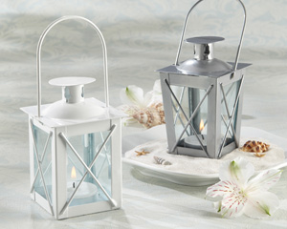 |  | Luminous Mini-Lanterns  Item Number: SBK 14006WT: White  Item Number: SBK 14006SV: Silver  Let memories of your perfect day light the way. These perfectly charming and practical mini-lanterns are the ideal favour. They add mystery and height to your table decor, while impressing your guests with their substance and thoughtfulness. Each aluminum lantern stands 5" high with a removable lid that makes lighting the replaceable tea light easy. Choose from glossy white or brushed silver. | R55.50
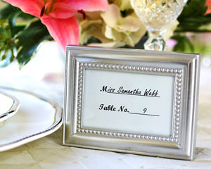 |  | "Beautifully Beaded" Photo Frame/Placeholder  Item Number: SBK14013NA  Picture this bit of elegance enhancing each place setting at your resplendent event! Fill the gleaming metal frame with a place card or a favourite photo. When they take this lovely favour home, your happy guests will fill the frame with a favourite photo of their own. Features and facts:  - Metal frame is embellished with dainty, beaded design  - Back of frame is covered with black velvet  - Preprinted, ready-to-personalize table card included  - Frame measures 10cm x 7.6cm | R24.00
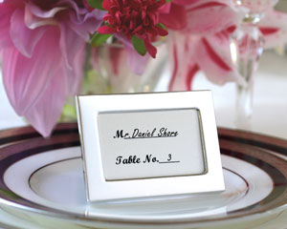 |  | Memories by the Dozen - Set of 12 Miniature Photo Frames/Placeholders  Item Number: SBK14016NA  These sweet miniature photo frames add silver shine and clean lines to your reception tables. Sold in sets of twelve, these mini-frames elegantly direct all of your guests to their reception tables, and later can be used to frame their own wallet-sized photos. Function meets finesse! Frame measures 5.1cm x 6.3cm. | R150.00
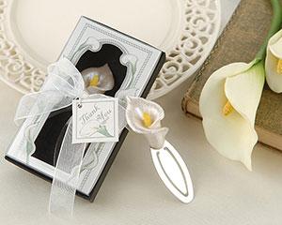 |  | 'Remember Romance' Calla lily Bookmark in Gift Box  Item Number: SBK 14021NA  The enchanting calla lily is a traditional wedding symbol known for its longevity and for its finesse. Guests will remember the romance of your special day each time they see the beautiful calla lily peeking from above the pages of their favourite book. Each calla lily favour is packaged in a dainty gift box resembling a calla lily garden trellis with the pearlescent calla lily and stainless steel marker upon a contrasting black base. A sheer white organza ribbon is then wrapped around the box with a thank you card attached. Measures 3 1/2" x 3/4". | R24.00
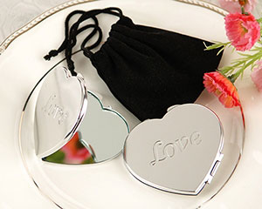 |  | "Love" Heart-Shaped Compact Mirror in Black Velvet Pouch  Item Number: SBK14022NA  Let your favours be a reflection of what's in your heart, and no favour expresses it more exquisitely and precisely than the “LOVE” Heart-Shaped Compact Mirror. The gleaming chrome, heart-shaped design is simply dazzling! Features and facts:  - Chrome heart compact has LOVE engraved on the front  - Elegantly presented in a black-velvet pouch  - Compact measures 6.4cm x 5.7cm | R32.00
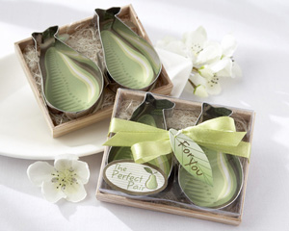 |  | “The Perfect Pair” Cookie Cutters in Wooden Gift Box  Item Number: SBK14025NA  Harvest a roomful of delight at your event with a deliciously sweet favour as useful as it is adorable! “The Perfect Pair” cookie cutters will remind your guests that you were made for each other each time they pop a tasty, pear-shaped, home-baked cookie in their mouth. Nestled closely together in a 9.5cm x 7.6cm decorative wood gift box with a straw bed and a clear top, the two stainless-steel cookie cutters surround decorative pear background and measure 7cm x 4.5cm. Brightening the gift box is a pear-green, satin ribbon with a “For You” tag in leaf design and a sticker that declares you’re “The Perfect Pair”. | R16.30
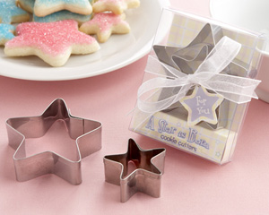 |  | “A Star is Born” Star-Shaped Cookie Cutters with Gift Box and Organza Bow  Item Number: SBK14027NA  Roll out the red carpet—and the cookie dough—for the world’s newest star, who surely deserves a cookie for bringing such sweetness into our lives! Brighten up your baby shower tables with this soon-to-be famous favour that’s destined for stardom, too. Your guests will love this favour and the tasty treats to come when they take them home. Made of stainless steel, the nested cookie cutters come in two sizes (3.8cm and 6.3cm), both in a playful yellow, pink and blue plaid gift box. “A Star is Born” appears on the front of the box, and a sheer, white organza ribbon and bow with a star-shaped “For You” tag completes the presentation. The gift box measures 6.3cm x 8.2cm x 1.9cm. | R23.00
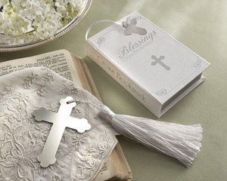 |  | “Blessings” Silver Cross Bookmark with Tassel in Keepsake Book Box  Item Number: SBK 14036NA  Christenings and baptisms mark especially meaningful moments in our lives—memorable moments we share with those who hold an important place in our hearts. Mark the moment and remind them of your love and appreciation by giving them the “Blessings” Silver Cross Bookmark, fittingly presented in a keepsake book box.  This inspired design features a 4 ½” long, pure-white tassel and a 2 ¾” x 2” cross, where the three-leafed clover end caps represent the trinity as well as faith, hope and love. The 4” x 2 ½” x ¾” gift box, a miniature replica of the bible, has decorative, silver accents, silver “pages,” a white-satin bookmark ribbon with a tiny, white budded cross, and the cover is imprinted with a small, silver cross and the words “Blessings Cross Bookmark.” | R30.50
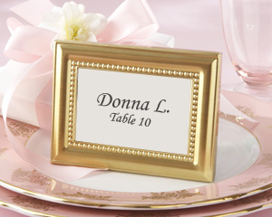 |  | Beautifully Beaded Gold Photo Frame/Place Holder  Item Number: SBK14039GD  Waiting behind crystal-clear glass surrounded by beads of bright gold is the perfect place for a favourite photo of the happiest couple you know—a thoughtful gift of appreciation your wedding guests will always treasure. Or use this Beautifully Beaded Photo Frame as place holders, letting your guests save their favour for a favourite photo of their own.  The finely crafted, versatile, glass-and-metal frame, with its gleaming brushed-gold patina, has a velvety-black finish on the back. This elegantly detailed photo frame measures approximately 7.6cm x 10cm. | R25.00
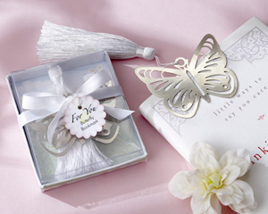 |  | “Butterfly” Silver-Metal Bookmark with White Silk Tassel  Item Number: SBK14042NA  With its stunning, polished-metal openwork, our “Butterfly” Silver-Metal Bookmark rises a step above elegance. The pure-white silk tassel simply adds to the remarkable beauty of a gift your guests will use and treasure always.  Designed to create a butterfly “garden” at your wedding reception, bridal shower or Sweet 16 celebration, the butterfly bookmark is delightfully presented in a display gift box adorned with cheery flowers in pastel shades of pink, blue and lilac with light-green accents. A white, grosgrain ribbon and bow with matching, flower-shaped “For You” tag complete the gift for presentation. The butterfly bookmark measures 5 h x 5.5 w with a 9cm tassel, and the gift box measures 9cm by 7.6 by 2cm. | R28.00
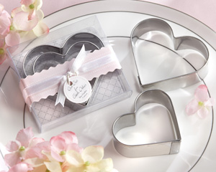 |  | “Cut Out for Each Other” Stainless-Steel Heart-Shaped Cookie Cutters  Item Number: SBK14045NA  Treat your guests to a wedding favour that's both meaningful and tasteful. Speak from the heart with these charming heart-shaped cookie cutter favours—a sweet way to say “thank you” and be remembered. Features and facts:  - Two stainless-steel, heart-shaped cookie cutters  - Larger heart measures 6.3cm wide; smaller heart is 5cm wide  - Cookie cutters nest in clear gift box decorated with scalloped, pale-pink band tied with white-grosgrain ribbon and matching “Cut Out for Each Other” tag  - Gift box measures 6.3cm h x 6.9cm w x 1.9cm d | R22.15
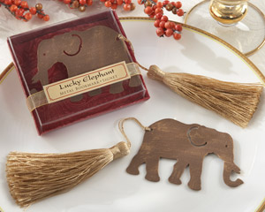 |  | "Lucky Elephant" Metal Bookmark with Elegant Gold Silk Tassel  Item Number: 14046GD  It's the tail of the elephant that tells this story! Who else would be clever enough to design the gift presentation for our lovely "Lucky Elephant" bookmark so that the elephant's gold tassel tail hangs intriguingly outside the gift box? Let this distinctive, meaningful favour bring good luck to all your guests.  Features and facts:  • Rich bronze-colored metal elephant bookmark with elegant gold silk tassel tail  • Elephant bookmark measures 3 ¼" w x 2 ¼" h  • Tassel is 5 ½ " long  • Ruby-paisley gift box with gold organza band and color-coordinated appliqué with the words "Lucky Elephant" Metal Bookmark  • Gift box measures 3 ½ " w x 3" h x ¾ " d | R29.50
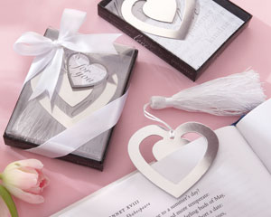 |  | "Love Story" Silver-Finish Heart-Shaped Bookmark with Elegant Silk Tassel  Item Number: SBK 14047NA  You're about to turn the page on another chapter in your life, and this time it's a love story. The gleaming “Love Story” Heart-Shaped Bookmark lets you share heartfelt feelings about one of the most exciting journeys you'll ever make. Express the joy of the occasion without saying a word. Features and facts:  - Stylish, silver-finish bookmark design portrays a heart within a heart  - Classic L-O-V-E graphic with a heart for the "O" adorns the inner heart  - Elegant tassel is white silk  - Heart bookmark measures 2 ¼ " h x 2 ¼ " w; tassel measures 5" l  - Gift presentation includes clear display cover on a black base encircled by heartfelt words like love, kindness, faith, trust, patience, and hope; the same words appear on the white background inside the box; a white-grosgrain ribbon and bow with a heart-shaped "For You" tag complete the presentation  - Gift box measures 3 ¾ " h x 2 ¾ " w x ½ " d | R28.50
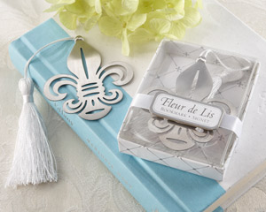 |  | Fleur-de-Lis Metal Bookmark with Elegant White-Silk Tassel  Item Number: 14057NA  Imagine the incredible memories of your event coming to mind every time your guests open the books they're reading! You can make that happen simply by thanking them for sharing your day with our exquisite Fleur-de-Lis Bookmark. It makes your story a best-seller! Features and facts  • Regal, silvery, openwork-metal fleur-de-lis bookmark with elegant white silk tassel  • Bookmark measures 2 3/4" h x 2 1/2"w  • Gift presentation includes clear-covered white gift box with criss-cross fleur-de-lis design, a white-satin band and Fleur de Lis applique  • Gift box measures 3 1/4" h x 2 1/2" w x ¾” d | R28.50
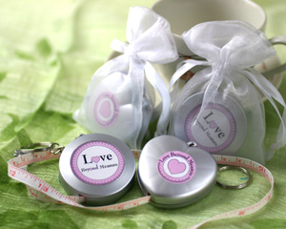 |  | "Love Beyond Measure" Measuring Tape Keychain in Sheer Organza Bag  Round: SBK18002RN  A gift to be enjoyed by all! Not only will these creative favours look splendid at a place setting, but your guests will find them as a useful tool to have around the house. Each compact measuring tape retracts at the push of a button and can easily be stored in a purse or on a handyman's pegboard. Available in round or heart shapes, these useful favours double as a keychain and feature a label that reads "Love Beyond Measure". These inventive favours are presented in a sheer white organza pouch with matching satin ribbon and are sure to add just that special touch you were looking for. Measures 5cm in diameter. The round tape extends to 150cm. | R17.00
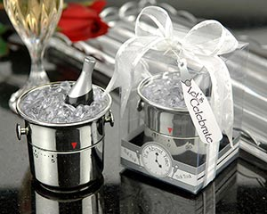 |  | "It's About Time! Let's Celebrate" Champagne Bucket Timer  Item Number: SBK18006NA  It's about time...to celebrate! This clever and elegant little favour adds polished silver-toned touches and works fabulously for any event. It's hard to decide what makes this favour more special—the fact that it is fully functional or its darling little details! Features and facts:  - Shiny, miniature "ice Cubes" surround a bottle of the "best bubbly" chilling in a silver-finish bucket, complete with little handles  - The bottom of the bucket twists to countdown any interval of time from 1 minute to sixty minutes  - Showcase gift box includes a sheer, white organza ribbon and matching bottle-shaped gift tag reading "Let's Celebrate!"  - Timer is 5.7cm high  - Gift box measures 7cm x 9.5cm | R48.50
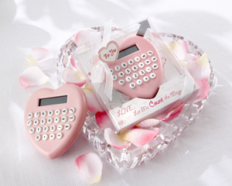 |  | “Love…Let Me Count the Ways” Heart-Shaped Calculator  Item Number: SBK18016PK  Add an extra measure of heartfelt emotion, multiplied by the endless love in your heart, minus any doubt, and you have newlyweds destined never to be divided!  The soft-pink heart has white buttons with easy-to-see, black characters below the LED read-out. Artfully packaged in a clear gift box, the calculator sits on a white background and cardboard pedestal filled with hearts of silver and pink. On the pedestal are the words “Love…Let Me Count the Ways” Heart Calculator. A cardboard, silver arrow seems to “pierce” the calculator. The gift box, which measures approx 12cm x 10cm, is completed with a heart-shaped “For You” tag tied with a sheer, white organza ribbon and bow. | R15.00
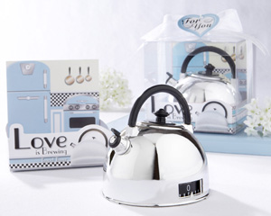 |  | "Love is Brewing" Teapot Timer in Classic Retro Gift Box  Item Number: SBK18018NA  A tea-timeless favour that creates wonderful memories! This nostalgic, silver-finish teapot kitchen timer is as quaint, cute and endearing as its gift box—a presentation that will impress your guests! Features and facts:  - Retro teapot timer is made of high-quality plastic  - Details include a black handle and lid, a tiny, black pour spout, and black-and-white timer numbers that appear in a small window on the side of the teapot  - Timer twists at the bottom to count down from one to sixty minutes  - Clear gift box includes a fabulous graphic of a vintage kitchen with a blue refrigerator and stove. In front of the teapot, the package reads "Love is Brewing" Teapot Timer alongside the image of a teapot  - Gift box includes a sheer, white organza ribbon and bow and a matching, heart-shaped "For You" tag  - Teapot measures 7.6cm high x 7.6cm in diameter  - Gift box measures 8.9cm2 | R48.50
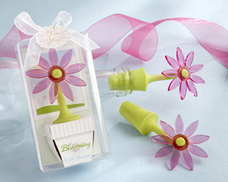 |  | “Blooming” Flower Bottle Stopper in Whimsical Window Gift Box  Item Number: SBK18022PK  Inspired by the vibrant, breathtaking beauty that rises from April’s rains and sunny days, we bring you the “Blooming” Bottle Stopper—a unique wedding favour designed to delight your guests at the reception and when they take them home. Bursting forth from the supple, spring-green stopper and stem is a translucent pink flower with a green center. As enchanting as the flower is the presentation.  The flower “grows” in a pretty, little lavender pot inside a clear display gift box. On the front of the flower pot, it reads “Blooming Bottle Stopper.” Behind the pot is a “window” that looks out onto a sunny spring day, with bright-blue sky, white clouds and a lovely field of flowers. A sheer, white organza ribbon and bow and matching, flower-shaped “For You” tag complete the presentation. The “Blooming” Bottle Stopper measures 10cm h x 5cm w, and the gift box measures 11.4cm h x 6.3cm w x 3.8cm d. | R29.00
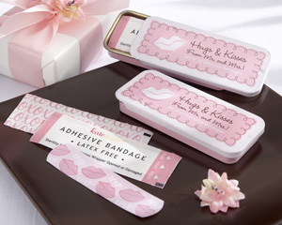 |  | “Hugs & Kisses from Mr. & Mrs.!” Adhesive Bandages in Reusable Tin  Item Number: SBK18025NA  Paging Dr. Love! In the long-held tradition of kissing boo-boos to make them feel better, Sparkling Bride goes a step further and throws in some hugs, too, with our unique, first-aid wedding favour—another feel-good gift in our “Hugs & Kisses from Mr. & Mrs.!” collection. Features and facts:  - Slide-top tin contains 10 outer-wrapped, pastel-pink adhesive bandages adorned with bright-pink lips and white XOXO's  - Outer paper wrapping is white with pink accents; one side is covered with a pink XO pattern and the other says ADHESIVE BANDAGE/LATEX FREE/ Sterility Guaranteed Unless Wrapper Opened or Damaged  - Adhesive bandage measures 6.3 x 1.3cm  - Bandage tin is pink with white accents that include raised lips on the sliding lid, which says Hugs & Kisses from Mr. & Mrs.! in black and Set of 10 Adhesive Bandages in white  - Tin measures 7.6 x 3.2cm | R16.70
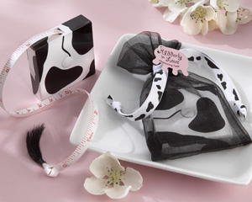 |  | “Udderly in Love” Measuring Tape with Cow-Tail Pull  Item Number: SBK18026NA  Kick up your cowgirl heels with a western- or farm-themed bridal shower or rehearsal dinner that declares the happy couple is “Udderly in Love!” How deep is their love? Your guests can measure it with this cute, cow-inspired measuring tape—a favour that's sure to put everyone in a good moooood! Features and facts:  - Cow-print plastic case holds 150cm measuring tape  - Measuring tape retracts at the touch of a button  - Tape measure pull is an adorable, brushy, black “cow tail”  - Measures approximately 5cm square  - Delightfully presented in a sheer, black-organza pouch with a cow-print, grosgrain-ribbon drawstring and a pink tag that says 'Udderly in Love' Measuring Tape | R19.10
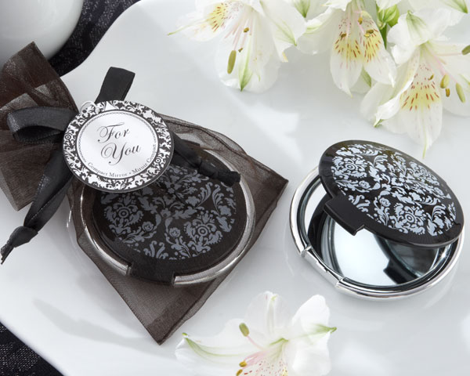 |  | "Reflections" Elegant Black-and-White Mirror Compact  Item Number: SBK 18030BK  Behold true beauty—inside and out! The “Reflections” mirror compact has a stunning, sophisticated, black-and-white damask design, and inside, just like the outside, we see a stunning, sophisticated face. Wherever girls are gathered in celebration, this incomparable compact is the ideal party favour. Features and facts:  - Round, reinforced plastic compact with silver-finish base and exquisite black-and-white damask design on cover  - Contains one standard mirror and one magnifying mirror  - Compact measures 2 ½ " in diameter  - Gift presentation includes black-organza bag with black-satin drawstring and coordinating "For You" tag | R39.50
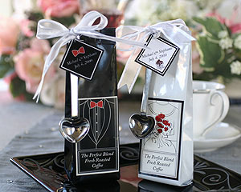 |  | The Perfect Blend - Elegant Coffee Kit  Black Groom: SBK19001BM  These elegant favours are sure to warm the mugs (and hearts) of your guests. Standing 16.5cm tall, they also add height and drama to your table decor. Each glossy black and white packet is illustrated with a sophisticated bride or groom. Inside the bag are 69g of delicious ground coffee and the entire favour is finished off with a delicate chrome heart-shaped coffee spoon, attached with a darling white meshed ribbon. Irresistible! Choose from Bride or Groom design, this coffee kit has some assembly required. (Ribbon and coffee spoon arrive unattached) | R38.50
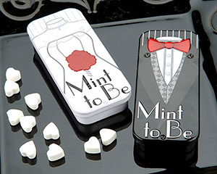 |  | 'Mint to Be' Bride and Groom Slide Mint Tins with Heart Mints  White Bride: SBK19002WT  Black Groom: SBK19002BK  Shout to the world that you are "Mint to Be" with the Bride and Groom Slide Mint tin. The slide is sleek! The slide is unique! The mints are cool! This favour's a jewel! Features and facts:  - Illustrated bride on the white mint tin cover holds a deep red rose bouquet  - Illustrated Groom is black and formal  - Cover of the tin easily slides aside to reveal dozens of tasty, heart-shaped mints  - Tin measures 7.6cm long by 2.5cm wide  - Choose from bride or groom design | R28.50
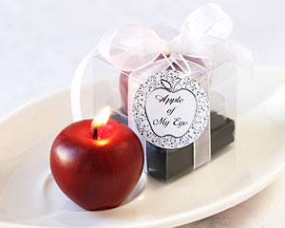 |  | "Apple of My Eye" Mini-Candle in Gift Box with Ribbon and Tag  Item Number: 20039NA  Sometimes the most charming things come in small packages. This little candle brings a big impact to any event: showers, parties, receptions, when ever! Hand-painted in a deep apple red,the wick is cleverly disguised at the apple's stem. Packaged in a clear showcase box, tied with sheer ribbon, candle stands approximately 1 1/4 inches tall. A standard Apple of My Eye tag is included. A matching personalized tag is also available with this favour | R29.75
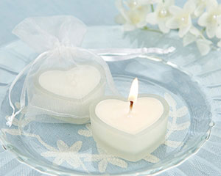 |  | 'HeartLights' Frosted Glass Heart Candles (Set of 4)  Item Number: SBK20045WT  Light your guests’ hearts with these classic frosted glass scented heart candles. Each glass heart candle is packaged in an elegant sheer white organza bag for a lovely presentation. We also suggest spreading some of these heartlight candles around as table decor to cast a romantic glow over every place setting. Candle measures 5.1cm at the widest point x 3.8cm in length. SOLD AS A SET OF 4. | R75.00/4
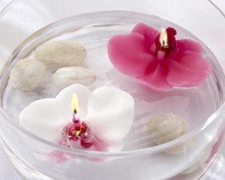 |  | Floating Orchid Candle (Pink, Set of 4)  Pink: SBK20092PK  When the delicate beauty of tropical flowers meets the soothing ambience created by a candle's glow, your event décor becomes uniquely memorable. Bring sparkle to your tables with splendidly designed floating orchid candles and set wonderful memories adrift.  - Beautifully detailed, floating wax candle  - Floating orchid available in pink  - Orchid measures 3cm h x 8cm w x 6.3cm d  - Sold in a set of four pink | R48.00/4
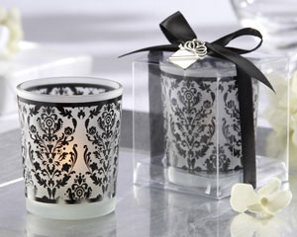 |  | “Damask Traditions” Frosted Glass Tea Light Holder with Charm (Set of 4)  Item Number: SBK20093BK  Taking elegant wedding favours to a whole, new dimension—the “Damask Traditions” Tea Light Holder brings style to your reception tables and radiant memories to your guests. Just picture these gorgeous thank-you gifts at each place setting, and you'll know. Features and facts:  - Elegant, black, damask-style pattern surrounds the frosted-glass tea light holder  - Tea light holder measures 6.3cm h x 5cm in diameter  - Clear gift box is accented with rich, black grosgrain ribbon and bow and signature, silver-finish gift charm  - Gift box measures 7cm h x 5.7cm w x 5.7cm d  - Tea light included  - Sold in sets of four | R100.00/4
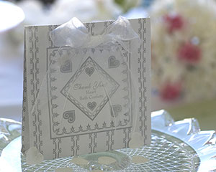 |  | Sweet Heart Bath Confetti  Item Number: SBK21017SV  You want your favours to not only thank your guests, but to one day remind them of you and your very special day. What better way than to give them these lovely packets of heart-shaped bath confetti. This confetti starts out as handfuls of sweet hearts which melt into a hot rose-scented bath. Heaven! Each favour is packaged in a prettily-printed standing envelope that says "Thank You" and tied with a sheer organza ribbon. Envelope measures approximately 10 x 10cm. The white bath confetti comes in a silver and white envelope. | R17.00
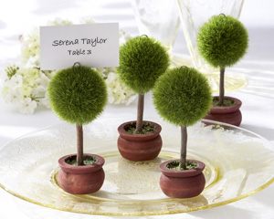 |  | Topiary Photo Holder/Place Card Holder (Set of Four)  Item Number: SBK22011GN  A breathtaking topiary—always the stunning showpiece of an exquisitely arranged garden—is the inspiration for this dramatic design. The Topiary Photo Holder/Place Card Holder will bring the same engaging charm to your wedding reception tables. Nobly rising from a well-crafted, dark-wood planter is the finely manicured, round, rich green foliage—an artisan’s hallmark. Every topiary can hold a cherished photo of the happy couple or a place card. The topiaries, which come in sets of four, measure 10cm h x 5cm w | R91.00
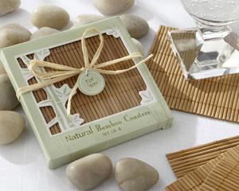 |  | Natural Bamboo Eco-Friendly Coaster Favours (Four Coasters per Favour!)  Item Number: SBK22014NA  Bamboo is a symbol of luck and success because of its strength, resilience and ability to grow quickly. It is said that bamboo is luckiest when you receive it as a gift, which makes these beautiful, Natural Bamboo Coasters a thoughtful favour for almost any occasion! Features and facts:  - Includes four bamboo coasters  - Coaster measures approximately 9cm  - Bamboo-green, die-cut picture-window gift box has white accents, a subtle bamboo design on the box, a natural raffia tie, and a matching, round “For You” tag  - Gift box measures approximately 10.2cm square | R32.50
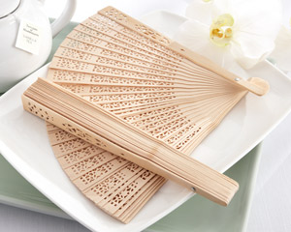 |  | "Sandal Season" Sandalwood Fan (Set of 12)  Item Number: 22016NA  Heaven-sent for your outdoor event! Keeping your guests cool is truly a breeze with this exquisitely exotic sandalwood fan. The astounding, intricate openwork enhances each burst of cool, refreshing air. Your guests will become great fans of this favour! Features and facts:  - Sandalwood fan with exquisitely detailed openwork  - Fan measures 8" l x 1" w x 3/4" d closed; 13 1/2" w open  - Sold in a set of 12 | R295.70/12
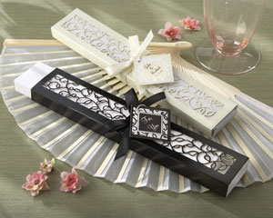 |  | Luxurious Silk Fan in Elegant, Laser-Cut Gift Box (Black or Ivory, Set of 4)  Black: SBK22022BK  Ivory: SBK22022IV  Just the favour for your elegant occasion under the sun! Glistening guests will thank you exuberantly when you thank them with a fabulous fan to keep them cool and content during your event. Features and facts:  - Pure-white, translucent, folding silk fan has a smooth bamboo frame  - Fan measures 21cm h x 2.5cm w (closed;) opened fan measures approximately 21cm h x 36cm w  - Intricately designed gift box design features a delicate, laser-cut leaf-and-vine pattern, with "For You" tag  - Gift box, available in ivory or black and accented with an ivory or black satin ribbon and bow, measures approximately 22cm x 3.8cm w 1.2cm d  - Matching personalized tags available at an additional charge  - Each color sold in a set of 4 | R146.06
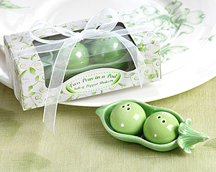 |  | Two Peas in a Pod - Ceramic Salt & Pepper Shakers in Ivy Print Gift Box  Item Number: SBK 23008GN  Handpainted in garden greens, this tiny set of ceramic salt and pepper shakers will charm your guests. Each shaker is dainty and detailed and reusable time and again. Add a cheerful touch to any special event you may be having. Guests of all ages will love this sweet little favour! Showcase box frames the clear window with an adorable curling ivy print. Box measures 5 inches long by 2.5 inches wide. | R43.00
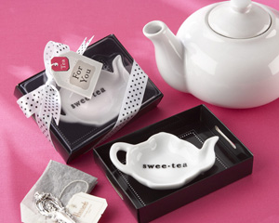 |  | “Swee-Tea” Ceramic Tea-Bag Caddy in Black & White Serving-Tray Gift Box  Item Number: SBK23019WT  Simply tea-rrific! Sparkling Bride has transformed a popular term of endearment into an exceptional favour brimming with creativity—one that’s certain to quench your thirst for an original “thank you” gift. The classic white, ceramic teapot-shaped, tea-bag caddy with “Swee-Tea” imprinted on it waits to be “served” in a thoughtfully designed, black tray with clever touches like cut-out “carrying handles.” The teapot measures 5 x 9 x 2.5cm and the display gift box, smartly accented with a black-and-white polka-dot ribbon and bow and tea-bag-shaped “For You” tag, measures 7.6 x 10 x 4cm. | R18.50
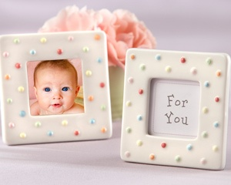 |  | "Delightfully Dotted" Ceramic Polka-Dot Photo Frame  Item Number: SBK 23024NA  A rainbow of polka-dots sprinkled on cream, a place for a photo, a reason to dream. Can you imagine a more heartwarming baby shower favour than one that provides a very special place for baby's first photo? Sparkling Bride knows cute, and this sweet-as-pie picture holder is proof of the pudding. Features and facts:  • Creamy-white ceramic frame with pastel polka dots in red, pink, blue, green, orange and yellow  • Frame opening holds 1 ½" square photo  • Back of frame is gray velvet with easy-to-use clasp for adding photos  • Ceramic frame measures 3" x 3"  • Favour arrives in white box with "For You" insert in photo space | R25.50
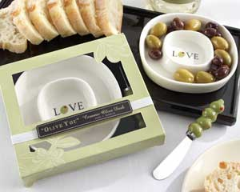 |  | “Olive You” Olive Tray and Spreader  Item Number: SBK 23025WT  We all love a little "dish" now and then, so spread some around at your next celebration! They'll all be talking about you and your extraordinary taste in favours when you thank your guests with Sparkling Bride’s "Olive You" Olive Dish and Spreader. Filled with LOVE (it says so right in the center!) and practical pizzazz, our fresh and fabulous favour says "Olive You" more! Features and facts:  Set contains olive dish and a stainless-steel spreader  • White, ceramic olive dish has two concentric sections and the word "LOVE" in the center with an olive in place of the "O"  • Olive dish measures ¾" h x approximately 4 ½" in diameter  • Stainless-steel spreader handle is four ceramic olives with red "pimentos"  • Stainless-steel handle measures approximately 4 ½" l x ¾" w  • Olive dish and spreader rest on black base inside gift box  • Gift box is sage green, with a subtle, white olive grove design on the back white, cutout olive-branch accents framing the clear, display window and a band of white-grosgrain ribbon with an appliqué that reads "Olive You Ceramic Olive Dish"  • Gift box measures 1" h x 5 ¾" w x 5 ¼" d | R85.66
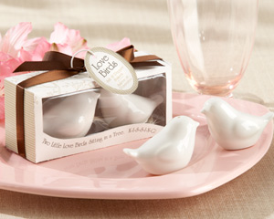 |  | “Lovebirds in the Window” Ceramic Salt & Pepper Shakers  Item Number: 23033WT  With your hearts flying high, you want to everyone to know how you feel about each other! Say it simply and sweetly on your wedding day with our "Lovebirds in the Window" Salt & Pepper Shakers. Just as these two spices enhance the flavour of your favourite fare, this whimsical wedding favour spices up your reception tables and dazzles your guests with exceptional taste. Features and facts:  • Stylish set of white, ceramic, bird-shaped salt and pepper shakers  • Birds nested in natural raffia  • Each shaker measures 1 ½ " h x 2" w x 1 ¼ " d  • Gorgeous gift presentation includes light-brown, matte-finish gift box which displays the shakers behind clear, plastic window; delicate line graphics of trees and a branch with two kissing lovebirds appear on the tag. A chocolate brown-satin ribbon and bow complete the presentation  • Gift box measures approximately 2 ¼ " h x 4 ¼ " w x 1 ½” d | R48.50
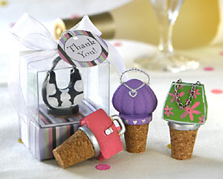 |  | So Pretty Miniature Purse Bottle Stoppers in Gift Box (Set of 4)  Item Number: SBK25020NA  Talk about favours that are sure to make your girls grin! Half funky, half fancy, these bottle stoppers are very useful and just plain retro-fabulous. Each set contains four different handpainted purse designs and each purse arrives in a box that's almost as cute as the stopper itself (and that's saying a lot!) Each box stands 7.6cm tall. | R86.00/4
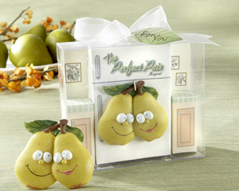 |  | “The Perfect Pair” Refrigerator Magnet in Retro Kitchen Gift Box  Item Number: SBK25034GN  Opposites may attract, but "The Perfect Pair" Refrigerator Magnet is certain to draw rave reviews from your guests! Beaming with the look of love, the colorful, resin pair brings a breath of fresh air to anyone's kitchen, including their own. They're right at home in a comfortable kitchen setting, cuddling happily on their refrigerator, all displayed in a clear gift box that measures 11.4cm x 9.5cm, topped with a sheer organza bow and a leaf-design "For You" tag. | R16.30
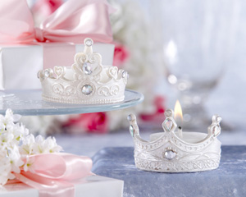 |  | "Royal Tea Lights" Jeweled Tea Lights (Set of Four Prince or Four Princess)  Crown: SBK25041CN  Tiara: SBK25041TR  Any celebration of royal magnitude calls for distinctive touches and incomparable favours, worthy of the majestic emotions embracing your heart. With “Royal Tea Lights” Jeweled Tea Lights on your tables, your guests are enthroned when they take their seats, instantly recognizing the depth of your love, esteem and gratitude. The elaborately crafted, pearlescent crowns contain perfectly placed, faux jewels, creating grandeur and sparkle befitting the occasion. Each 3.8cm high x 5cm diameter crown arrives with a tea candle. Sold as a set of four prince crowns or four princess tiara tea lights. | R66.50/4
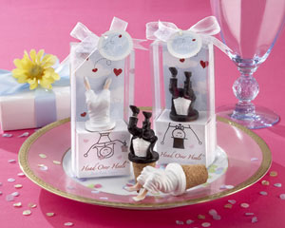 |  | “Head Over Heels™” Bride or Groom Bottle Stoppers  Bride: SBK25047WT  At last, it’s your wedding day, and you can hardly contain your emotions. As much as you’d love to, you simply can’t do cartwheels down the aisle, so let your wedding favours express the joy in your heart! The “Head Over Heels™” Bride or Groom Bottle Stoppers say it so eloquently, though a tad “unceremoniously,” and that’s what makes them so much fun! Choose the groom, with the bottom half of his black tux, white vest and tails topping the stopper, or let the bride do flips at the table, where guests will get a seldom-seen view of her white gown and shoes.  Both the bride and the groom stoppers measure approximately 7.6cm h x 2.5 w, and each is playfully presented in a 13cm x 5.1cm x 3.2 display gift box. Behind them is a light-blue sky filled with white, fluffy clouds and crimson hearts. Below them is a white, cardboard pedestal, and on the front of the pedestal are delightful drawings that show the rest of the couple. Just beneath them are the words “Head Over Heels™ Groom (or Bride) Bottle Stopper. They’re sold individually, but they’re so much in love—they’re clearly meant to be together! | R25.50
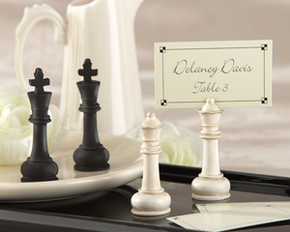 |  | "Check Mate!" King and Queen Place Card/Photo Holder (Set of 4 Assorted)  Item Number: 25048NA  When it comes to chess and elegant favours, be sure you make the right move. When these regal place card/photo-holding kings and queens are on your guest list, everyone at the table feels like a VIP, and they know it's going to be an unforgettable knight! Features and facts:  • Antique-finish resin king and queen chess pieces  • One pair in black and one in white  • Slit at top holds place card or photo  • Chessboard-themed place cards included  • Chess pieces measure approximately 2 3/4" h x 7/8" in diameter  Sold in a set of 4 | R93.50/4
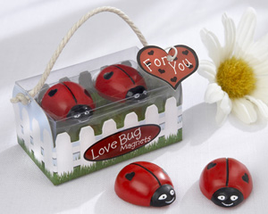 |  | “Love Bug” Ladybug Magnets  Item Number: SBK25054RD  Who are the love bugs you're celebrating? An ultra-affectionate, engaged couple having a garden wedding? A new baby on the way? Family and friends at your annual barbecue? Everyone loves having these little bugs around! Features and facts:  - Two darling, red-and-black ladybug magnets have sweet, smiling faces and tiny, black hearts on their plump, red backs  - Adorable, “backyard” gift box places the two little love bug magnets on a grass-green tier surrounded by a white-picket fence and blue sky  - Dainty braided-rope handle and a red, heart-shaped “For You” tag with black heart accents complete the presentation | R25.50
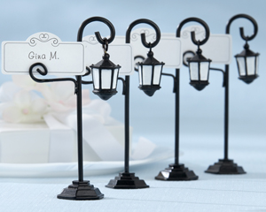 |  | “Bourbon Street” Streetlight Place Card Holder with Coordinating Place Cards (Set of 4)  Item Number: SBK25057BK  Let a nostalgic expression of days gone by lead the way to your happy occasion. Guests will feel like they are in a historic place full of old-world charm as this clever streetlight favour shows them the way to their seats with a place card that looks like a street sign. Delightfully unique! Features and facts:  - Gracefully crafted, metal-and-resin streetlight is black with painted, white “glass” windows in the lamp  - Streetlight measures approximately 10.7cm h x 7.6cm w (with place card)  - Place card with scroll design included  - Sold in a set of four | R96.03
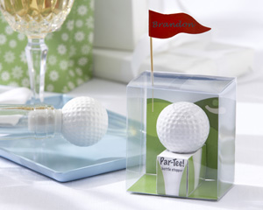 |  | “Par-Tee” Golf Ball Bottle Stopper with Flag Place Card  Item Number: SBK25058WT  It's rough when you're looking for unique golf favours. You can drive all day and never find a more tee-rrific favour for golf fanatics than the “Par-Tee” Golf Ball Bottle Stopper, purely designed to make your next invitational a winner! Features and facts:  - Realistic, resin golf ball sits atop white, rubber stopper that looks like a tee  - Red flag-stick place card included to insert at upper corner of gift box  - Bottle stopper measures 6.4cm h x 4.5cm in diameter  - Golf course-themed, clear gift box places golf ball on a tee, and in the distance is the fairway, the green and a sand trap  - Gift box measures approximately 8.3cm h x 7cm x 4.5cm d | R27.60
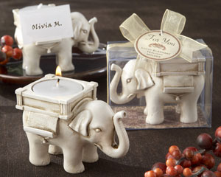 |  | “Lucky Elephant” Antique Ivory-Finish Tea Light Holder  Item Number: SBK25062IV  When East meets West, extraordinary and exotic favours come to pass. Behold the magnificent “Lucky Elephant” Tea Light Holder. Lucky because elephant statues, especially those with raised trunks, are considered a source of luck and good fortune. Lucky gift. Lucky guests! Features and facts:  - Stately elephant is handsomely detailed and crafted from resin with an antique-ivory finish  - Standard tea light candle fits in saddle  - Lipped rug under the howdah (that’s elephant for “saddle”) can hold a place card or photo on either side  - Elephant stands on a ornate, muted jewel-tone, paper Persian rug in the clear, display gift box  - Gift box includes rich, sheer gold, organza ribbon and bow  - Color-coordinated, round “For You” tag features delicate design accents and the words Lucky Elephant Tea Light Holder  - Tea light included  - Gift box measures 6.3cm h x 8.2cm w x 5.7cm d | R48.50
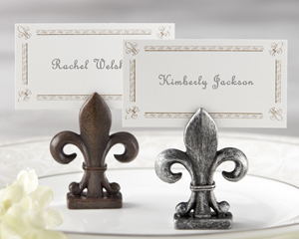 |  | "Fleur-de-Lis" Place Card/Photo Holder (Set of 4)  Item Number: SBK25063SV  The fleur-de-lis has been the epitome of European elegance for centuries, and this acclaimed design adds distinction and elegance wherever it appears. Let Sparkling Bride’s lovely "Fleur-de-Lis" Place Card/Photo Holder do the same for your next event. Features and facts:  - Finely detailed, resin fleur-de-lis has a slit at the top for place card or photo  - Fleur-de-lis available in dark-wood finish or antique-silver finish  - Matching place card with fleur-de-lis motif included  - Holder measures 2" h x 1 1/2" w x 1/2" d  - Sold in a set of four pewter antique finish | R57.00/4
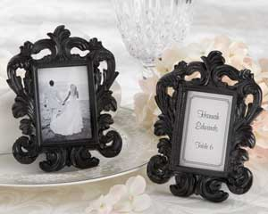 |  | "Black Baroque" Elegant Place Card Holder/Photo Frame  Item Number: SBK 25067BK  Rarely has there been a favour designed with such classic elegance. The artists have created this fashionable photo frame in 17th-Century Italian baroque style, where architecture, painting, sculpture, and the decorative arts combine to capture finely detailed movement. Whatever it holds—a place card or your favourite photo, our captivating baroque frame graces your tables with grandeur. Features and facts:  - Intricately designed, glossy black-resin Baroque photo frame  - Black back and stand with easy-open access to photo space  - Frame has 2 ½ " h x 1 ¾ " space for photo or place card  - Insert with coordinating accent can be used as a place card  - Baroque frame measures 4 ¾ " h x 3 ½ " w | R29.50
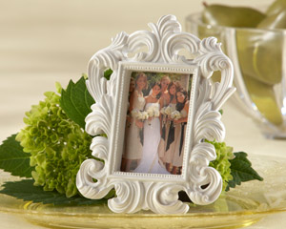 |  | "White Baroque" Elegant Place Card Holder/Photo Frame  Item Number: 25067WT  Designed to take your breath away! Stunning doesn't begin to describe this fabulous "White Baroque" frame. Masterfully crafted in lavish detail, this favour not only thanks your guests in grand style, it also becomes an intrinsic part of your table decor.  Features and facts:  • Stunning,baroque-style, resin place card holder/photo frame with matte-white finish  • Black back and frame stand with easy access to place card/photo space  • Frame measures 5" h x 3 1/2" w  • Place card/photo space measures 2 1/2" h x 1 3/4" w | R29.50
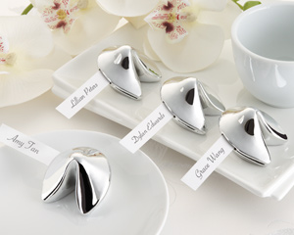 |  | "Good Fortune" Fortune Cookie Place Card Holder (Set of 4)  Item Number: 25074SV  Your guests will be lucky to find this favour at their seat! The slender card is just the right size to hold your guest's name or a sweet message from the lucky couple. A wonderful addition to your wedding, this silver-tone replica of a classic cookie will surely bring good fortune to your guests. Features and facts:  - Silver-tone fortune cookie with side slot to hold slender card, which can hold name or hand-written message  - Made of resin  - Sold as a set of four  - Fortune cookie measures 1 1/2" x 1 3/4" x 1"  - Name card measures 1 3/4" x ½” | R81.00/4
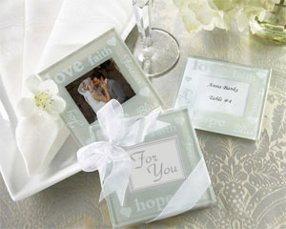 |  | "Good Wishes" Pearlized Photo Coasters  Item Number: SBK27015NA  Spread your good wishes and capture the moment in classic pearlized glass. Your moment...their moments, these gorgeous pearlized glass frame coasters will protect your memories forever. Good wishes you have for the future such as love, joy, hope, bliss, faith, and forever surround the frame. Crafted of heavy high quality pearlized glass, each coaster features four padded "feet" to protect surfaces. Present your guests with these lovely gifts in any number of ways: framing a photo, used as a placecard holder, inserted with a personalized tag of your name and event date, or simply displaying our beautiful For You insert (included.) Guests will love being able to bring them home and use the good wishes coasters to frame their own special photos! Packaged in twos and tied with a sheer organza ribbon, these stunning coasters will add a useful "touch of glass" to any reception table or bridal shower. (Coasters measure approx. 9cm x 9cm and fit photos approx. 4.4 x 5cm). | R37.50
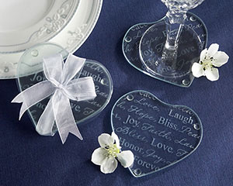 |  | "Good Wishes" Heart Glass Coasters  Item Number: SBK 27025NA  It’s funny how some words become more important on special occasions. Words like joy, hope, faith, bliss, honor, forever, and love seem more permanent, more certain, on a wedding day. These charming glass heart-shaped coasters carry these words of love beautifully etched across their top, reminding your guests of your important day. The many elegant fonts used for each word convey timeless sophistication. Each favour contains a set of two coasters and arrives packaged with a sheer organza ribbon, which makes a delightful presentation to your guests. Coasters measure 3.5” by 3.5”. | R33.00
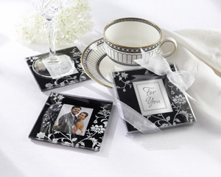 |  | "Timeless Traditions" Elegant Black & White Glass Photo Coasters  Item Number: SBK27032BK  Sentiments from your heart, surrounded by a divine, white-floral motif of blooms and leaves on a jet-black background. More than stunning glass coasters and the quintessential wedding favour, “Timeless Traditions” are the ideal combination of artistry, function and meaningful memories. The center frame arrives with a stylized “For You” card that can be easily replaced with a favourite photo or a place card. On the back of the 8.9cm x 8.9cm coasters are four, tiny plastic “feet” to protect valuable surfaces. Each coaster set is beautifully presented in a clear gift box tied with a charming, white organza ribbon and bow. Each set contains two coasters. | R37.50
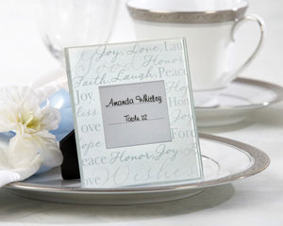 |  | "Good Wishes" Pearlized-Glass Photo Frame/Place Card Holder (Set of 4)  Item Number: SBK27034NA  Heartfelt hopes for joy, bliss, faith, laughter, honour, peace and love forever—the essence of a happy marriage—surround a special place for your guest’s name or a photo of the happy couple in a gorgeous frosted-glass photo frame. The words appear in white and silver lettering on a vivid pearl background that playfully captures the light and makes the wonderful wishes almost dance in the frame. The frame’s back and stand have a rich, black, velvety texture. A dramatic accompaniment for your tables and a meaningful gift for your guests to take home, each frame measures 9 x 9cm with space for a 3.8cm x 5cm photo in the center. Sold as a set of four. | R82.50/4
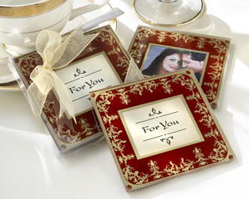 |  | “Imperial” Exquisite Glass Photo Coasters  Item Number: SBK27042BG  Infinite images of exotic, faraway lands—mysterious and rich with intriguing stories—are brought to mind simply by the distinctive and dramatic design on two squares of glass. What remarkable story will your event hold for the guests fortunate enough to receive this exquisite favour? Features and facts:  - A gorgeous, intricate gold and deep-burgundy design decorates this pair of coasters  - Center square contains a parchment paper-like insert that says “For You”  - “For You” insert can be replaced with a place card or photo  - Protective “feet” safeguard surfaces  - Clear gift box is accented with sheer gold organza ribbon and bow  - Coasters and gift box measure approximately 8.9cm2 | R29.50
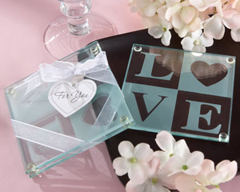 |  | "Clearly in Love" LOVE Glass Coasters (Set of 2)  Item Number: 27058NA  The word itself expresses emotion felt purely in the heart. That's what makes our classic, yet contemporary LOVE glass coasters a favourite of brides. The coasters bring special and unique meaning to everyone in the room, along with your heartfelt gratitude to each and every guest. Features and facts:  • Clear glass coaster with classic frosted LOVE design in which the O is a heart  • Coaster measures 3 1/2" square  • Clear gift box with white organza ribbon and elegant silver-and-white "For You" tag  • Sold in a set of two | 33.50
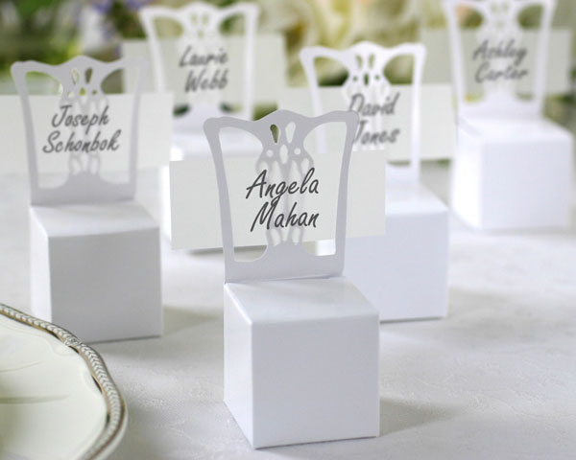 |  | Miniature Chair Placecard Holder and Favour Box (set of 12)  Item Number: SBK28002WT  For something so delicate, these favours sure work hard! They not only act as placecard holders, with their included vellum strip which serves as a place card, but inside the seat of the chair they hold several ounces of whatever favour filling you want.  Fill them up with flower petals, candies, seeds, potpourri or with chocolate, mints...almost any wedding favour you can think of!  Measures approximately 10cm tall when constructed and is sold in sets of 12. Fillable box measures 4.2cm square | R62.50/12
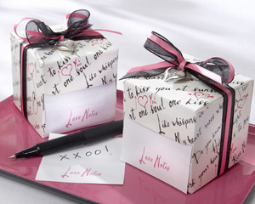 |  | "Love Notes" Sticky Notes in Nostalgic Dispenser Gift Box with Dainty Heart Charm  Item Number: SBK28012NA  In a gift box reminiscent of the heart-felt love notes passed in school, these endearing sticky notes whisper sweet nothings to your guests! A step above the typical sticky-note pad, this unique note dispenser is a perfectly fitted box that offers one note at a time, each one delicately etched with "Love Notes" in pretty pink—ideal for exchanging words of passion with someone you adore. Your guests will love you for it, and they'll remember your day fondly whenever they "make note" of their emotions.  The 5 x 5cm notes are engagingly presented in a white box sprinkled with pink hearts and enduring sentiments like "Hold Me Tonight", "One heart, one soul, one kiss" and "Do you know how much I love you?" A stunning, silver heart charm dangles from a pink-and-black bow of sheer organza and satin to complete this favour that speaks to everyone. | R33.00
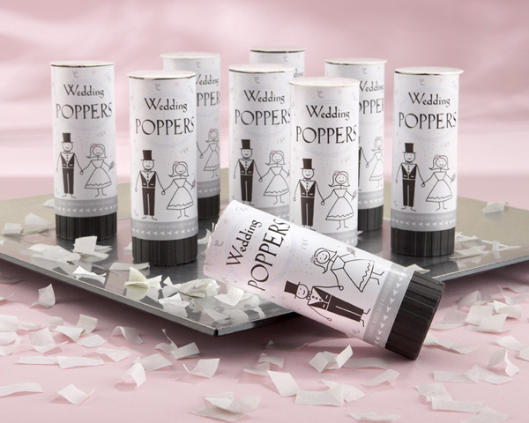 |  | Have a Blast Biodegradable Celebratory Wedding Poppers (set of 12)  Item Number: SBK28046WT  Heard the headlines? “Rice Toss Replaced by “Have a Blast!” Wedding Poppers! Big, Biodegradable Fun!” When you’ve got something to celebrate, and we know you do, give your guests the perfect alternative to rice before you rush from the reception to your honeymoon—“Have a Blast!” Wedding Poppers.  Imagine the jubilation, not to mention the fabulous photos you’ll create when your guests launch biodegradable tissue-paper confetti into the air by a safe, spring-loaded device. The perky popper wrapper, which gives guests instructions for use, shows a cartoon bride and groom holding hands, surrounded by festive confetti, with the words “Wedding Poppers” overhead. Nothing spreads the joy like confetti! Measuring 4 ¼” h x 1 ½” in diameter, the poppers are sold in sets of 12. | R198.93
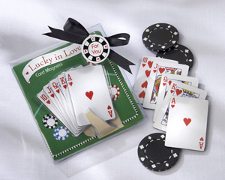 |  | "Lucky in Love" Playing Card Magnets (Set of Five)  Item Number: SBK28053NA  When hearts rule the day, love is never a gamble! While you may be holding the best hand, your guests can hold a winning hand themselves—one they’re sure to “stick” with! You can deal everyone a highly coveted royal flush at your Vegas-theme or casino-theme event with these “Lucky in Love” Card Magnets.  The five artfully packaged, 5.7cm x 3.8cm magnets, ten through ace of hearts, sit in a cut-out “hand” surrounded by red, blue and black poker chips on a green card table. At the top are the words “Lucky in Love.” The gift presentation measures 10.7cm x 10cm x 1.2cm, and a round, poker-chip “For You” tag dangles from a black, grosgrain ribbon and bow that accents this attractive, once-in-a-lifetime poker hand. | R17.00

Next Shipment Due June2011

BABY SHOWER RANGE

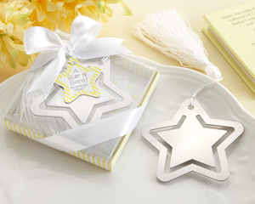 | "A Star is Born!" Metal Bookmark with White-Silk Tassel  Item Number: 14059NA  Baby doesn't even have to read for the part in the happiest show on earth! That new little star is already one for the books, and so is this "A Star is Born" Star Bookmark. Next to baby and the mom-to-be, this pretty, practical thank-you gift will be the star of the show! Features and facts:  • Gleaming, silvery brushed-metal, star-shaped bookmark with openwork design  • Luxurious white-silk tassel attached  • Metal bookmark is approximately 2 3/4" in diameter  • Gift box has yellow and white stripes, a clear display cover, a white-satin ribbon and bow and a color-coordinated, star-shaped tag  • Gift box measures 3 1/4" square | R29.50
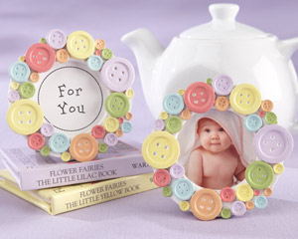 | "Cute as a Button" Round Photo Frame  Item Number: 25075NA  Mom always says, "Button up to stay warm and cozy!" We have a rainbow of buttons cozying up to create this adorable photo frame favour so full of warmth for baby showers! The funny thing is, our fantastic "Cute as a Button" photo frame makes thanking your shower guests a snap!  • Multi-colored, resin buttons in various sizes on a circular, white base with a gray frame stand on the back  • Center insert says "For You"  • Frame measures approximately 3" in diameter | R33.00
 | “Blessings” Silver Cross Bookmark with Tassel in Keepsake Book Box  Item Number: SBK 14036NA  Christenings and baptisms mark especially meaningful moments in our lives—memorable moments we share with those who hold an important place in our hearts. Mark the moment and remind them of your love and appreciation by giving them the “Blessings” Silver Cross Bookmark, fittingly presented in a keepsake book box.  This inspired design features a 4 ½” long, pure-white tassel and a 2 ¾” x 2” cross, where the three-leafed clover end caps represent the trinity as well as faith, hope and love. The 4” x 2 ½” x ¾” gift box, a miniature replica of the bible, has decorative, silver accents, silver “pages,” a white-satin bookmark ribbon with a tiny, white budded cross, and the cover is imprinted with a small, silver cross and the words “Blessings Cross Bookmark.” | R30.50
 | Tin Favour Pails (Silver)  Item Number: SBK 14005SV  These galvanized tin favour pails provide a simply charming presentation for favours. Fill these adorable pails with small treats, flower petals, seeds, shells, potpourri, or practically any favour filler and at the same time bring a decorative touch to your tables. The miniature buckets are available in a variety of colors to accent your event and each tin pail measures 2" x 2.25" . Sold as a set of 12 (1 dozen). | R150.00/12
 | Two Peas in a Pod - Ceramic Salt & Pepper Shakers in Ivy Print Gift Box  Item Number: SBK 23008GN  Handpainted in garden greens, this tiny set of ceramic salt and pepper shakers will charm your guests. Each shaker is dainty and detailed and reusable time and again. Add a cheerful touch to any special event you may be having. Guests of all ages will love this sweet little favour! Showcase box frames the clear window with an adorable curling ivy print. Box measures 5 inches long by 2.5 inches wide. | R43.00
 | "Love Story" Silver-Finish Heart-Shaped Bookmark with Elegant Silk Tassel  Item Number: SBK 14047NA  You're about to turn the page on another chapter in your life, and this time it's a love story. The gleaming “Love Story” Heart-Shaped Bookmark lets you share heartfelt feelings about one of the most exciting journeys you'll ever make. Express the joy of the occasion without saying a word. Features and facts:  - Stylish, silver-finish bookmark design portrays a heart within a heart  - Classic L-O-V-E graphic with a heart for the "O" adorns the inner heart  - Elegant tassel is white silk  - Heart bookmark measures 2 ¼ " h x 2 ¼ " w; tassel measures 5" l  - Gift presentation includes clear display cover on a black base encircled by heartfelt words like love, kindness, faith, trust, patience, and hope; the same words appear on the white background inside the box; a white-grosgrain ribbon and bow with a heart-shaped "For You" tag complete the presentation  - Gift box measures 3 ¾ " h x 2 ¾ " w x ½ " d | R28.50
 | “Butterfly” Silver-Metal Bookmark with White Silk Tassel  Item Number: SBK14042NA  With its stunning, polished-metal openwork, our “Butterfly” Silver-Metal Bookmark rises a step above elegance. The pure-white silk tassel simply adds to the remarkable beauty of a gift your guests will use and treasure always.  Designed to create a butterfly “garden” at your wedding reception, bridal shower or Sweet 16 celebration, the butterfly bookmark is delightfully presented in a display gift box adorned with cheery flowers in pastel shades of pink, blue and lilac with light-green accents. A white, grosgrain ribbon and bow with matching, flower-shaped “For You” tag complete the gift for presentation. The butterfly bookmark measures 5 h x 5.5 w with a 9cm tassel, and the gift box measures 9cm by 7.6 by 2cm. | R28.00
 | "Love Beyond Measure" Measuring Tape Keychain in Sheer Organza Bag  Round: SBK18002RN  A gift to be enjoyed by all! Not only will these creative favours look splendid at a place setting, but your guests will find them as a useful tool to have around the house. Each compact measuring tape retracts at the push of a button and can easily be stored in a purse or on a handyman's pegboard. Available in round or heart shapes, these useful favours double as a keychain and feature a label that reads "Love Beyond Measure". These inventive favours are presented in a sheer white organza pouch with matching satin ribbon and are sure to add just that special touch you were looking for. Measures 5cm in diameter. The round tape extends to 150cm. | R17.00
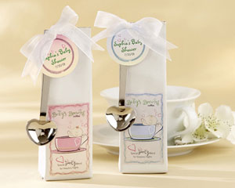 | "Baby is Brewing" Coffee Kit with Heart Scoops  Pink: SBK19003PK  Blue: SBK19003BL  Fill the hearts and mugs of your guests with this "Baby is Brewing" coffee. This favour is just what mom will need as well, with its special "hearty" blend that is sure to help after all those sleepless nights. A great way to get the morning started! Each glossy white pouch contains 69g of flavorful coffee and comes with a chrome heart-shaped coffee scoop that can be attached with the white organza ribbon. (Ribbon, coffee scoop arrive unattached) Coffee pouch measures 5.1cm x 15.8. | R38.50
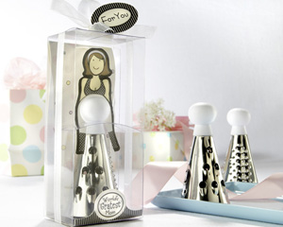 | “World’s Gratest Mom” Cheese Grater in Gift Box with Organza Bow  Item Number: SBK13013NA  Though millions of moms throughout the world are great, tell your new mom she’s “grater!” These merry moms in their cheese-grater “dresses” will dress up your baby shower tables delightfully and surprise your guests with their originality and charm. Standing in front of a colorful backdrop, the cute, cardboard cutout of “mom” appears to have a “baby belly” that’s actually the white handle of the stainless-steel cheese grater, which features three hole sizes for fine and coarse grating. This baby shower favour is beautifully displayed in a clear gift box that says “World’s Gratest Mom”, all accented by a lovely, sheer organza bow and a “For You” tag. The grater measures 8.9cm high, and the display gift box measures 13.9cm x 6.3cm x 5cm. | R33.00
 | “A Star is Born” Star-Shaped Cookie Cutters with Gift Box and Organza Bow  Item Number: SBK14027NA  Roll out the red carpet—and the cookie dough—for the world’s newest star, who surely deserves a cookie for bringing such sweetness into our lives! Brighten up your baby shower tables with this soon-to-be famous favour that’s destined for stardom, too. Your guests will love this favour and the tasty treats to come when they take them home. Made of stainless steel, the nested cookie cutters come in two sizes (3.8cm and 6.3cm), both in a playful yellow, pink and blue plaid gift box. “A Star is Born” appears on the front of the box, and a sheer, white organza ribbon and bow with a star-shaped “For You” tag completes the presentation. The gift box measures 6.3cm x 8.2cm x 1.9cm. | R23.00
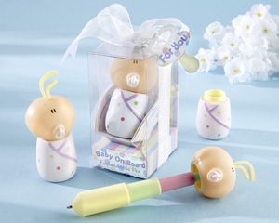 | “Baby On Board” Expandable Pen in Car Seat Packaging  Item Number: SBK18015NA  Sitting snug as a hug in a color-rich car seat is the “write” baby shower favour to drive everyone wild! This bundled-up baby heading down life’s highway is actually an expandable pen! The multi-colored, polka-dotted “baby blanket” is the base for the pen, and baby’s almost-bald head becomes the top of the colorful—yellow, light-green, pink and blue—telescoping pen. Cleverly contained in clear, gift-box packaging, this “noteworthy” baby rides comfortably in a cute, cardboard car seat covered with polka dots that match baby’s blanket. The pen is approximately 7.6cm high and 14cm high when expanded. The gift box measures 7.6cm high, 5.7cm deep and 4.4cm wide. | R35.00
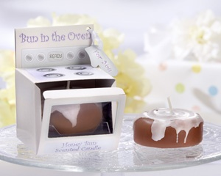 | “Bun in the Oven” Scented Candle (Set of 4)  Item Number: SBK20073NA  Fresh-baked enchantment! The captivating scent of cinnamon is as sweet as your celebration, making this clever baby shower favour a crowd-pleasing morsel that’s impossible to forget! Inside the clear window of a cardboard “stove” sits a 2” x 1” diminutive honey bun candle, perfectly brown, with tempting, white “icing” slathered generously over the top. The pale-yellow stove has knobs, burners and lavender accents. Across the stove’s top panel, it reads “Bun in the Oven”, and just below the clear, oven window is “Honey Bun Scented Candle” The heavenly honey bun and its clever gift box arrive complete with a “For You” tag in the shape of an oven mitt. The gift box measures 5.7cm x 5.7cm x 7.6cm. | R105.50/4
 | "Delightfully Dotted" Ceramic Polka-Dot Photo Frame  Item Number: SBK 23024NA  A rainbow of polka-dots sprinkled on cream, a place for a photo, a reason to dream. Can you imagine a more heartwarming baby shower favour than one that provides a very special place for baby's first photo? Sparkling Bride knows cute, and this sweet-as-pie picture holder is proof of the pudding. Features and facts:  • Creamy-white ceramic frame with pastel polka dots in red, pink, blue, green, orange and yellow  • Frame opening holds 1 ½" square photo  • Back of frame is gray velvet with easy-to-use clasp for adding photos  • Ceramic frame measures 3" x 3"  • Favour arrives in white box with "For You" insert in photo space | R25.50
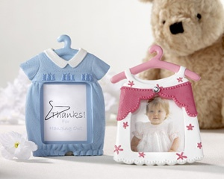 | “Thanks For Hanging Out” Photo Frame/Placeholders (Set of 4)  Blue: SBK25039BL  Pink: SBK25039PK  Thank guests for “hanging out” at the baby shower with these charming photo placecard holders. Truly unique, each holder will add lots of style to the table with its whimsical design. Featuring a little-boy-blue jumper or pretty-in-pink dress, each is centered around a clear frame reading “Thanks for Hanging Out.” Guests can use later to frame wallet-sized photos of the new arrival! Frame measures 5 x 6cm and is made of resin. (Choose between jumper and dress design) Sold in sets of four. | R68.00/4

Angleuv Goodies
angeluv.goodies@yahoo.com

